**CSE-3101 : WEB PROGRAMMING LABORATORY**

**Submitted To,**

**Sunanda Das**

Assistant Professor

Department of Computer Science and Engineering (CSE)

Khulna University of Engineering & Technology (KUET)

**Prottoy Saha**

Assistant Professor

Department of Computer Science and Engineering (CSE)

Khulna University of Engineering & Technology (KUET)

**Project Name: Advertisement Website(preOwned)**

**Name:** Saimoon Al Farshi Oman

**Roll: 1807018**

**Department:** Department of Computer Science and Engineering

**Course No.:** CSE-3100

**Course Title.:** Web Programming

**Group No.:** A1

**Year:** 3rd

**Semester:** 1st

**Date of Submission:** 21/7/2022

**Project Name:** Advertisement Website (preOwned).

**Introduction:**

This website is made to use by general person for finding or posting ads of old or new product at their nearest location. Here, one can create their own account to experience an better experiences.

* Here, one can find their required product ads thorough searching by category and location. One can also search with text related with any product like category, location, product title, product description, product price etc.
* User have to pay 2% of expected price and for each day user have to pay 1 TK (using SSLCOMMERZ payment gateway) for showing their ads on preOwned. User will get a payment confirmation mail to their email by preOwned.
* User will be able to see ads posted by them and payment receipt for each ads. They can also download the payment receipt.
* After 15 min user have to login again. As user’s session will be automatically destroy after 15 min. User can change their details and update password, they can also delete their ads and their accounts if they want to.

There will be some additional functionality for admin panel.

* View posted ads and have access to delete any ads which is in appropriate.
* View users details and can delete users.
* Can show the total users, total ads and total income by preOwned.

**Project Description:**

The basic structure of website has two parts.

1. User / Client Panel
2. Admin Panel
3. **User/ Client Panel:**

A user will show our homepage first where he will get several options like for login, post ad, show all ads, a search bar to search ads based on keyword or category or location. There are also some grid to show the ads based on category and location with attractive design.

The header section is designed with search option and navbar on the top.

The main section users can select ads using category and location. And footer at the last.

In register page, user will be able to create his account and log in to their account.

In all ads page, one can see all ads available on preOwned and a search bar and category and location filter option. There are category of mobile, electronics, vehicles etc. There are location of dhaka, chattogram, khulna etc.

While posting an ad user have to pay some amount to preOwned and can download payment receipt of that ad. After paying, a payment confirmation mail will be sent to users email.

From our website a user will get a better customer service if he face any issues.

User can see the details of an particular ad. Each ad will have some image of the product of that ad and contact details of user by whom the ad is posted.

Payment for ad is mandatory. User must have to pay some money for posting ad. Here SSL commerz payment getway is used for payment(demo version). Here API is called for managing a fruitful transaction.

There are a option of user profile. In profile user can update his/her details including password. In My receipt user can download payment receipt for ads. And in My ads user can see their posted ads and be able to delete their own ad.

There is also a dynamic feature to delete ads automatically from database after extending end date of that ad. After registration user will receive a welcome email to their email by preOwned.

Here is a flow diagram of User Panel given below:

**Home Page**

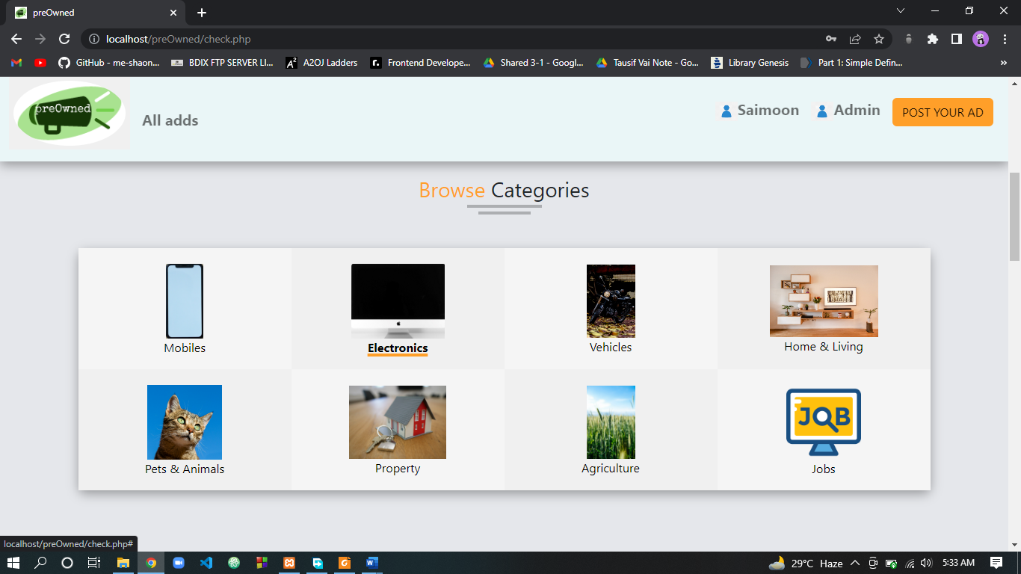

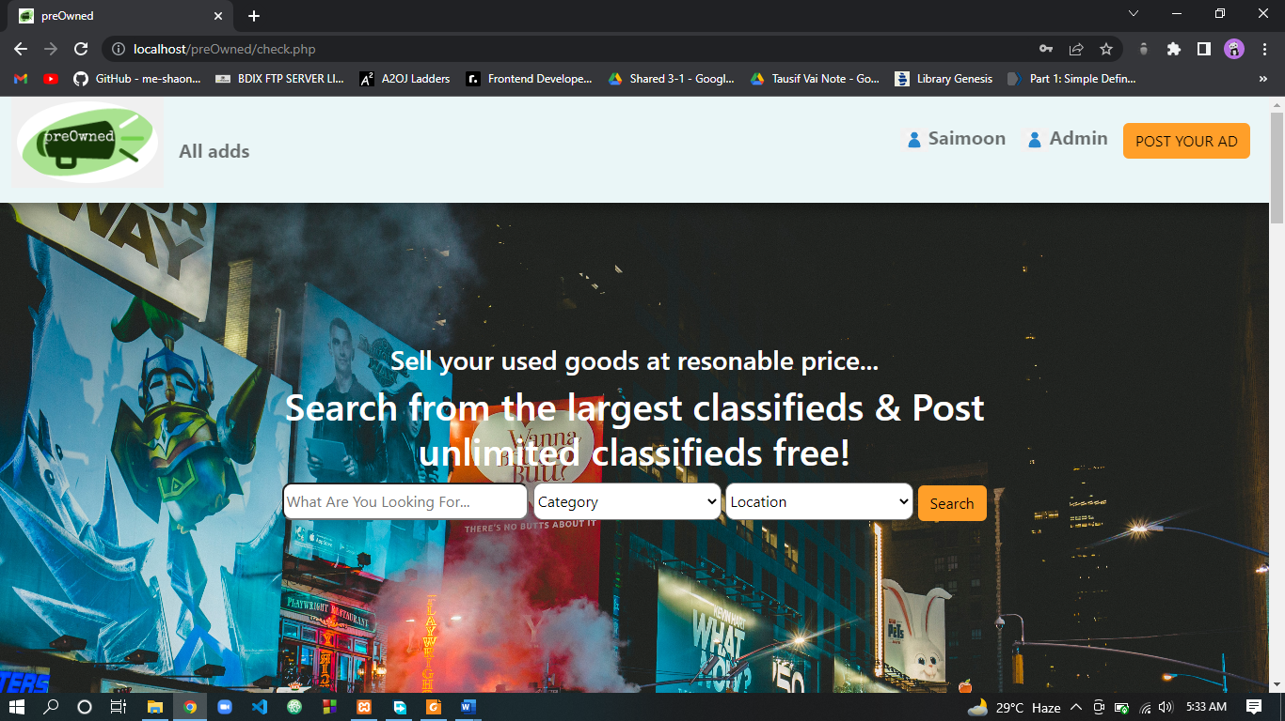

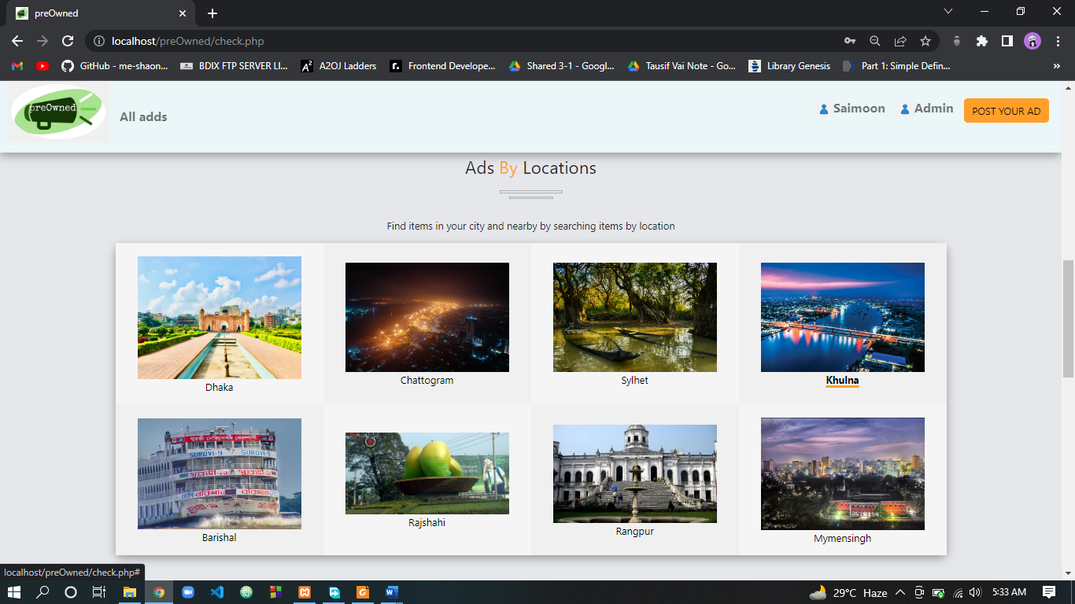

**Sign Up and Sign In Page**

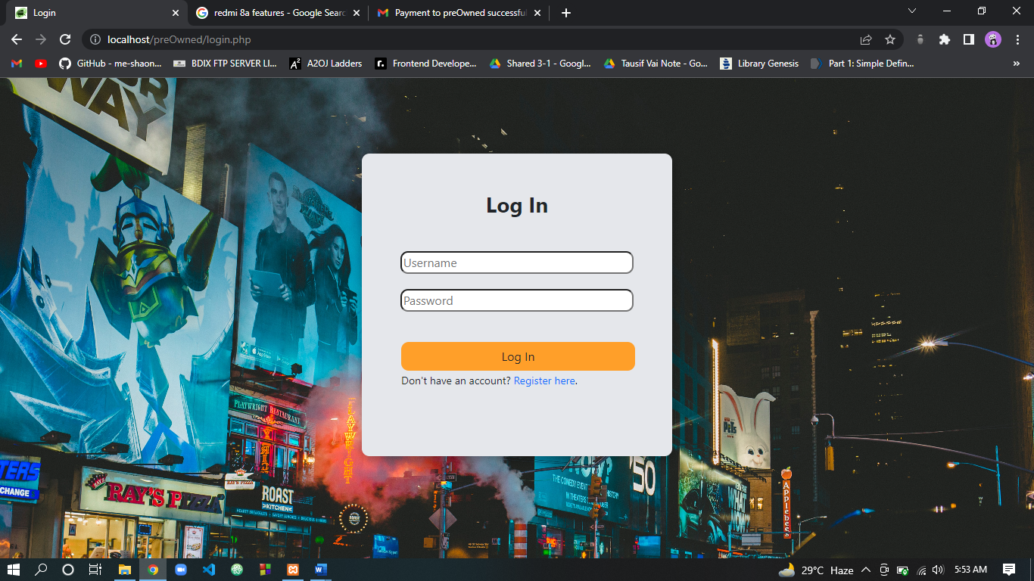

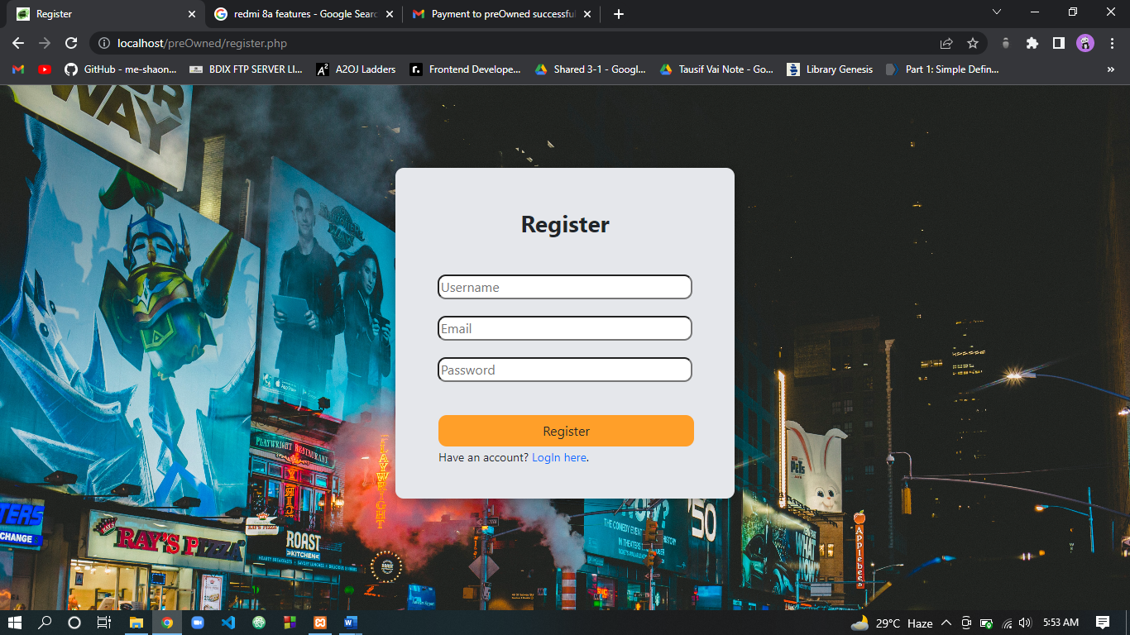

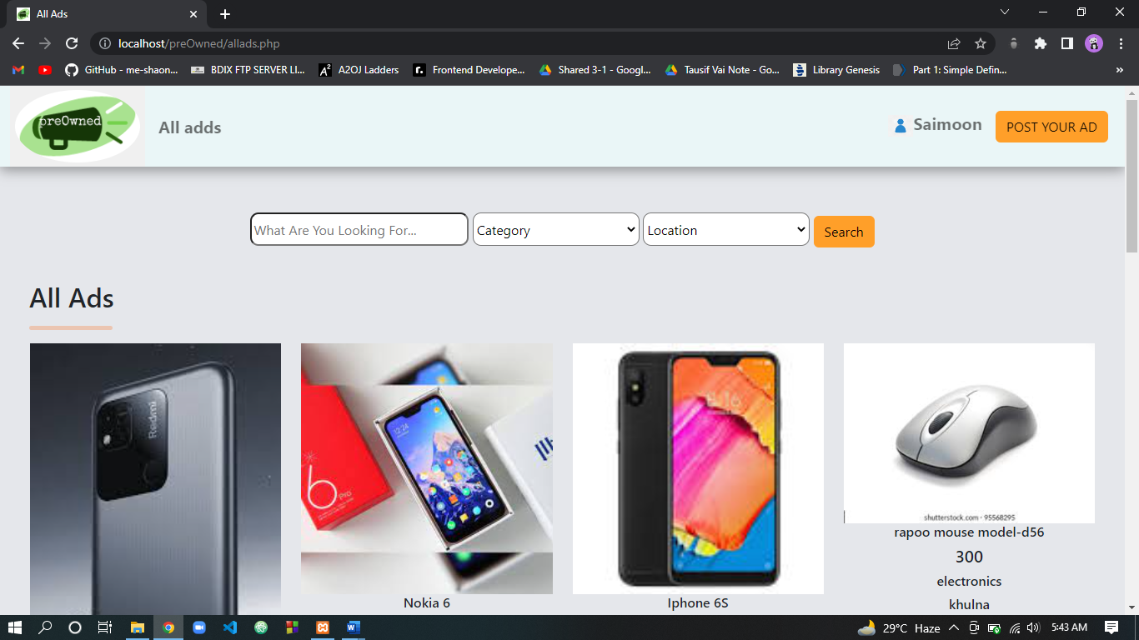

**All Ads Page**

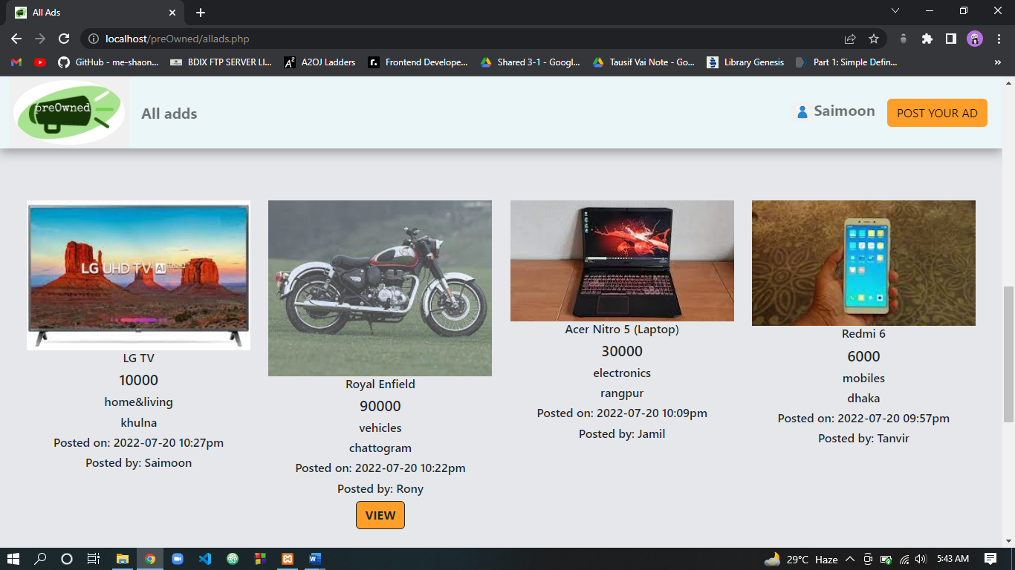

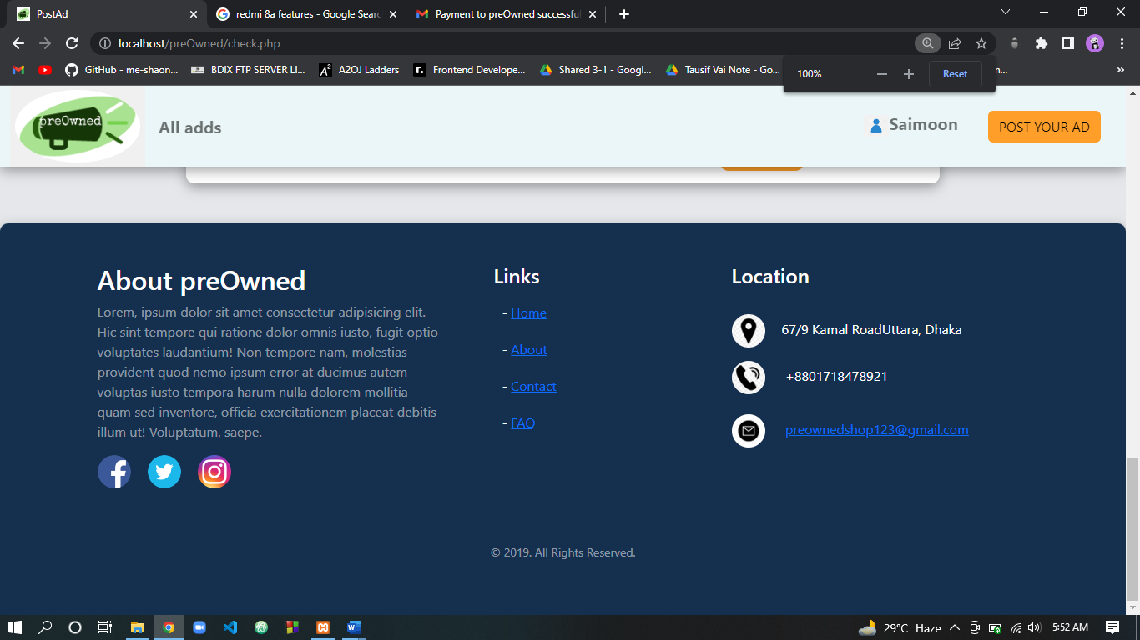

**Footer of a Page**

**Ad Details**

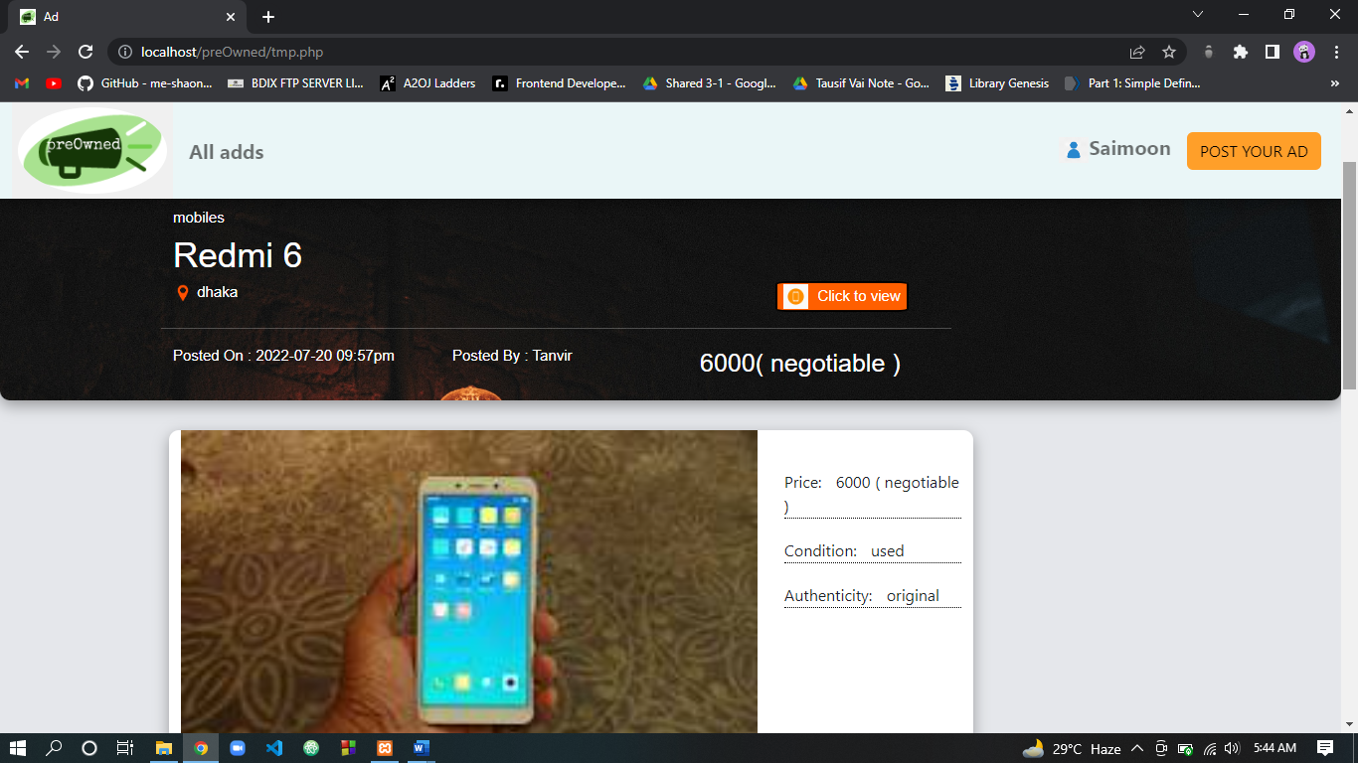

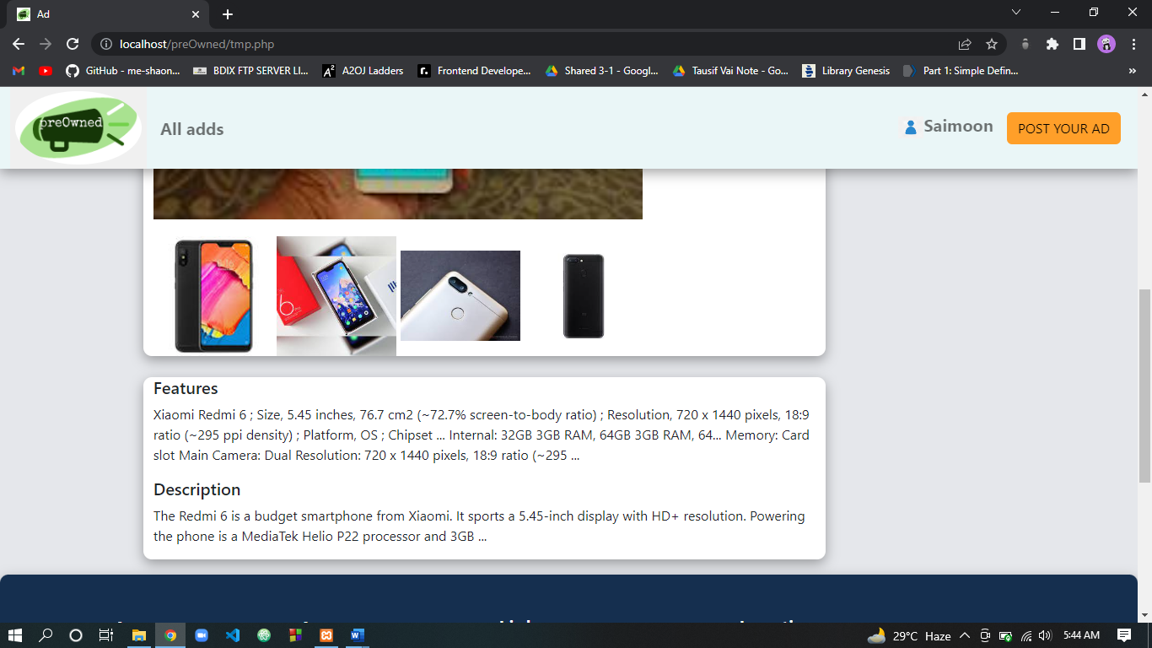

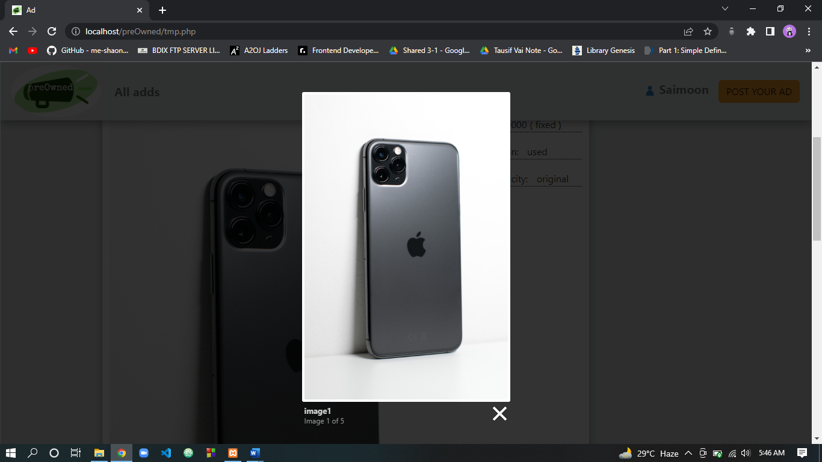

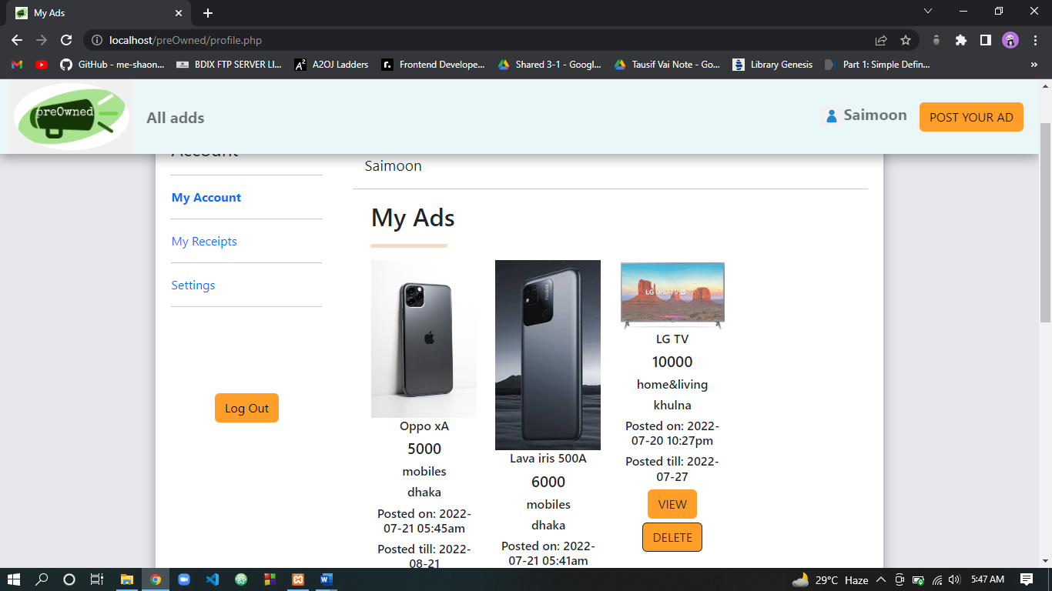

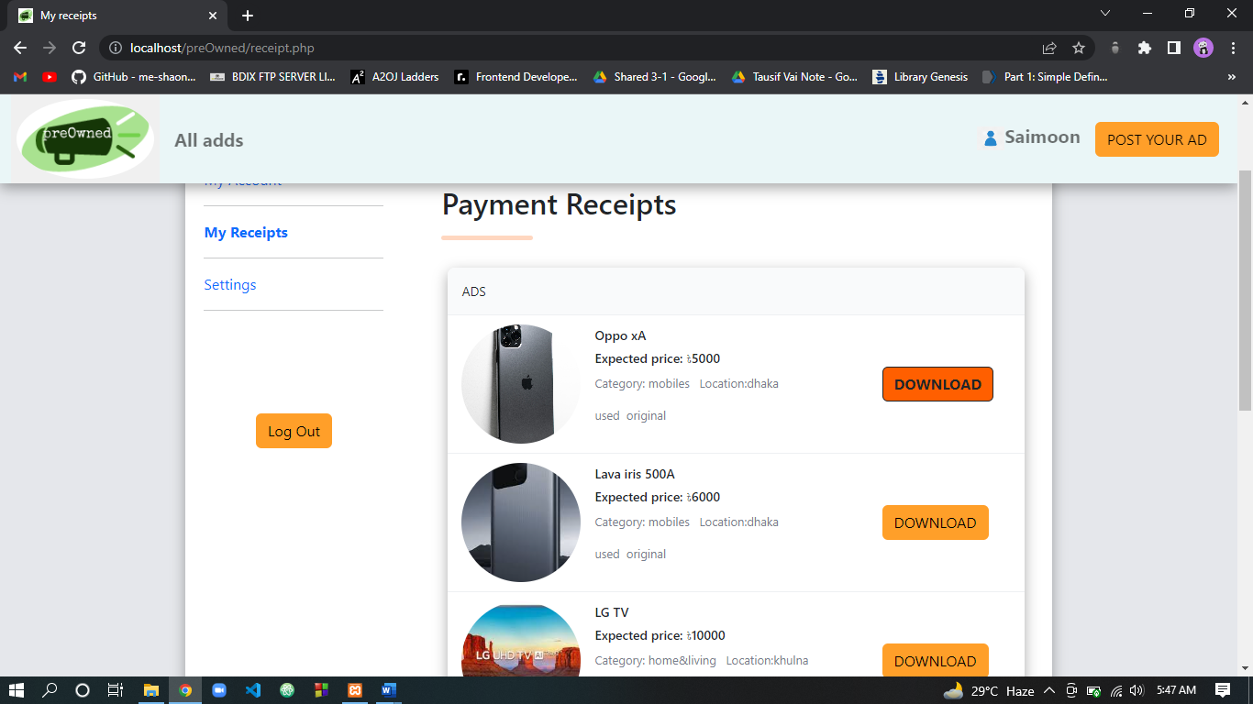

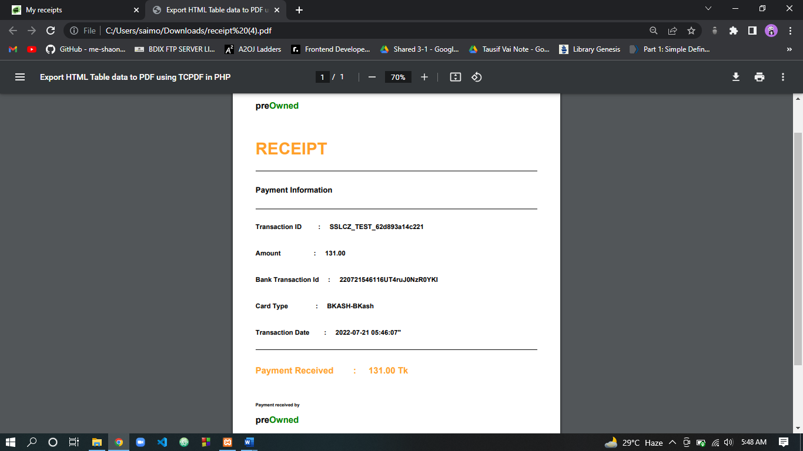

**Payment Receipt**

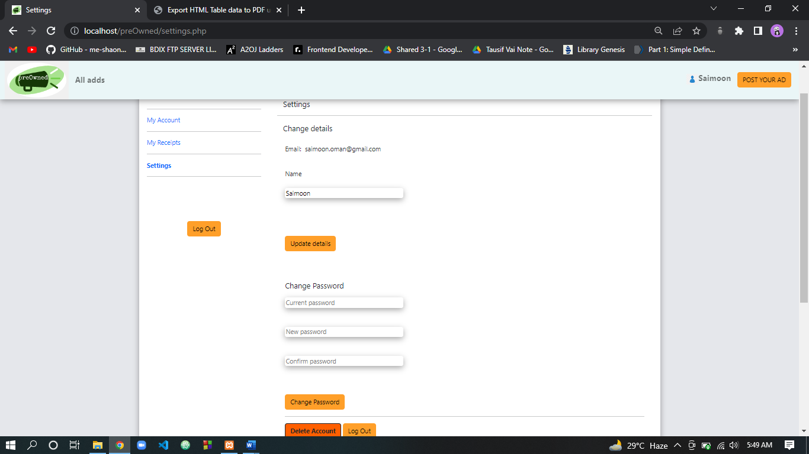

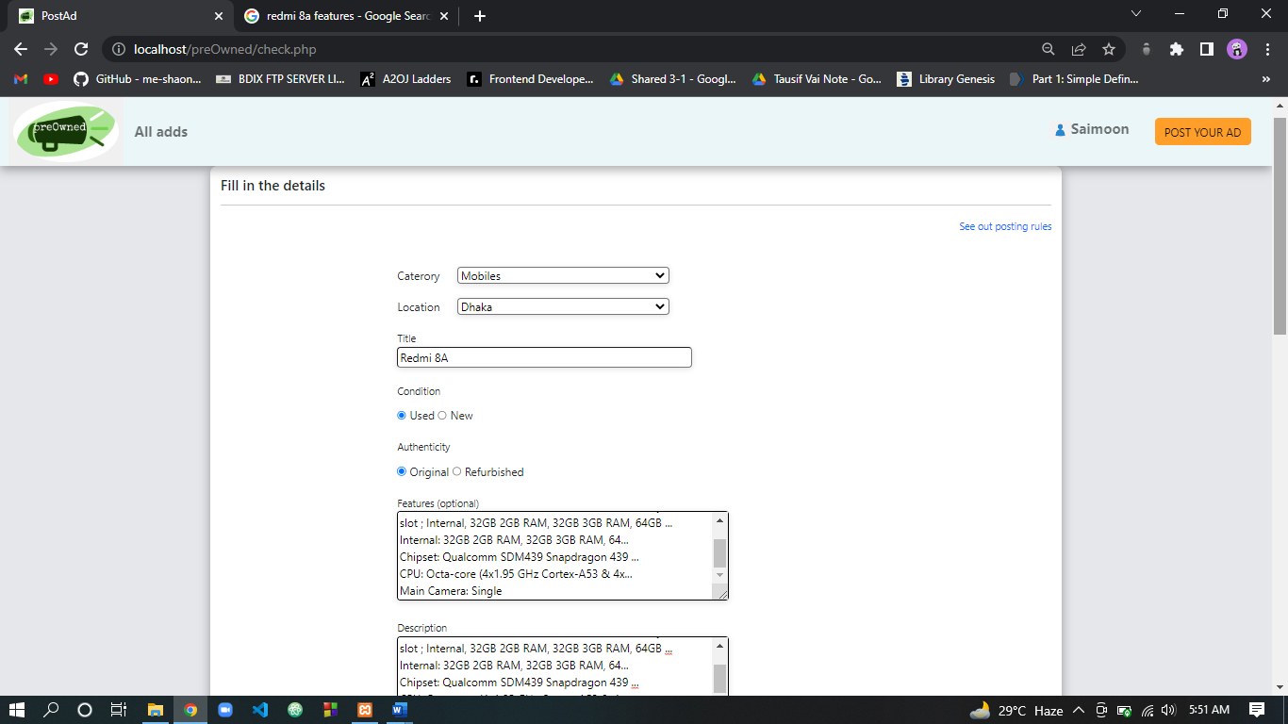

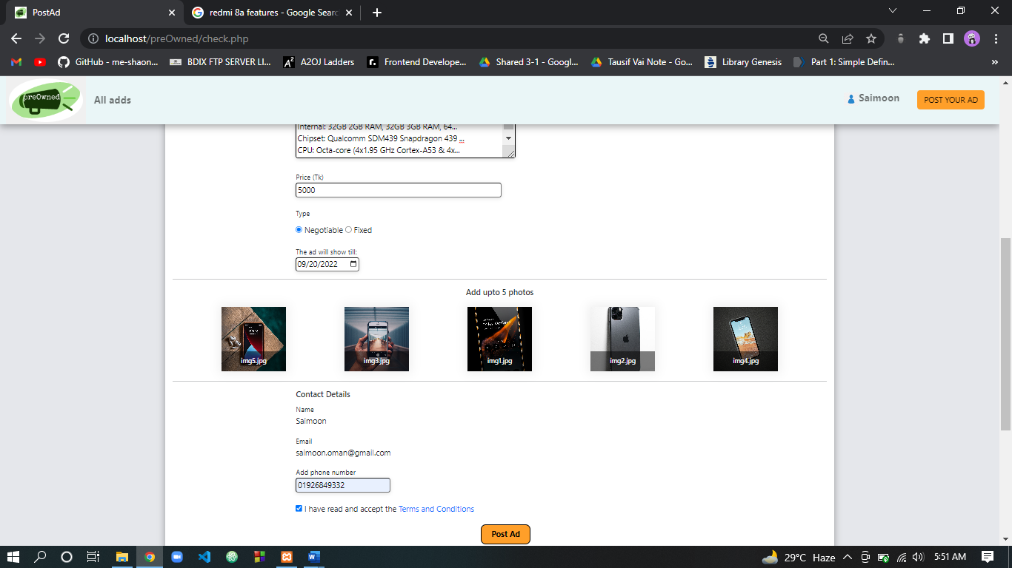

**Post Ad page**

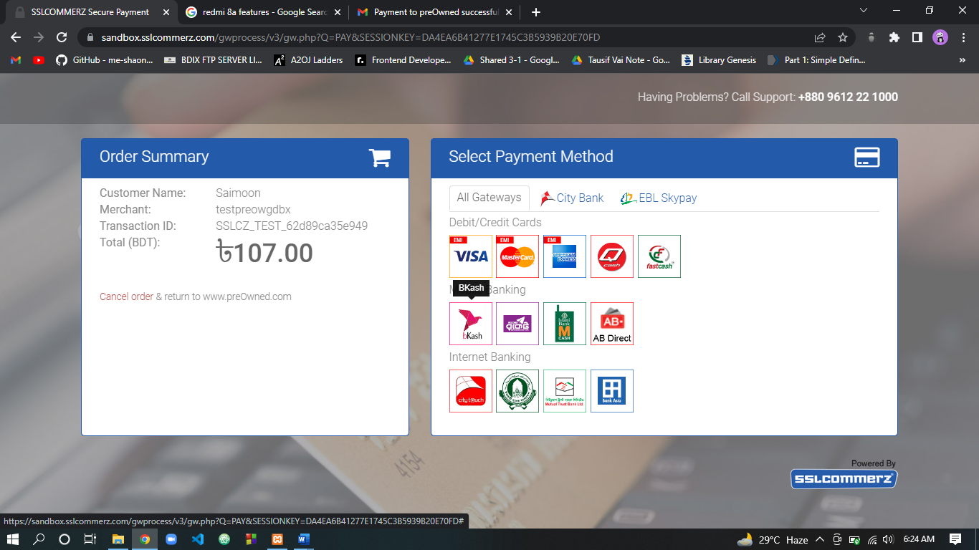

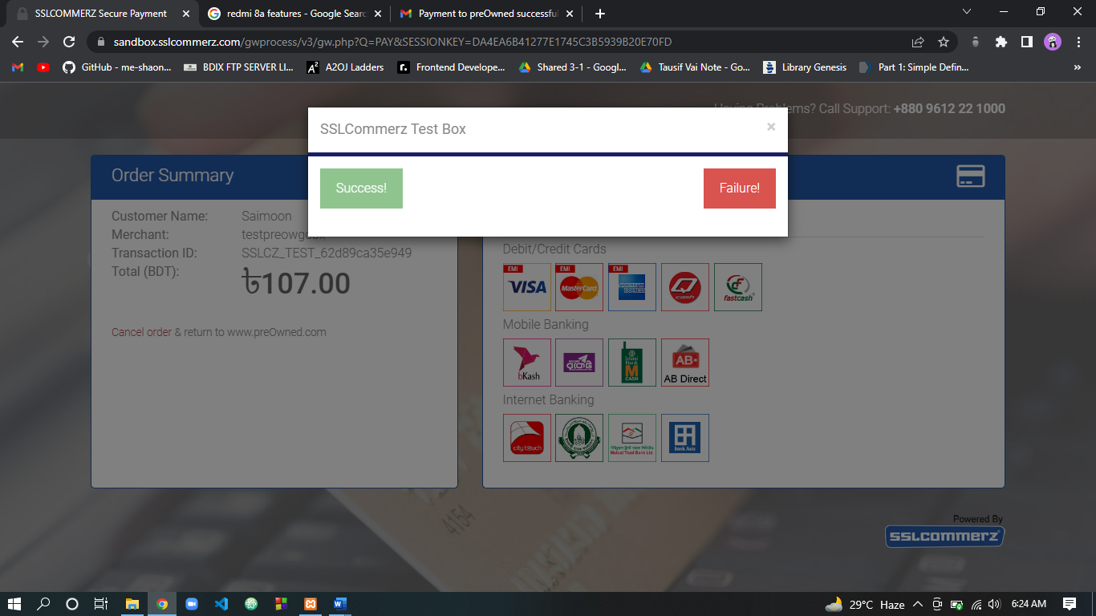

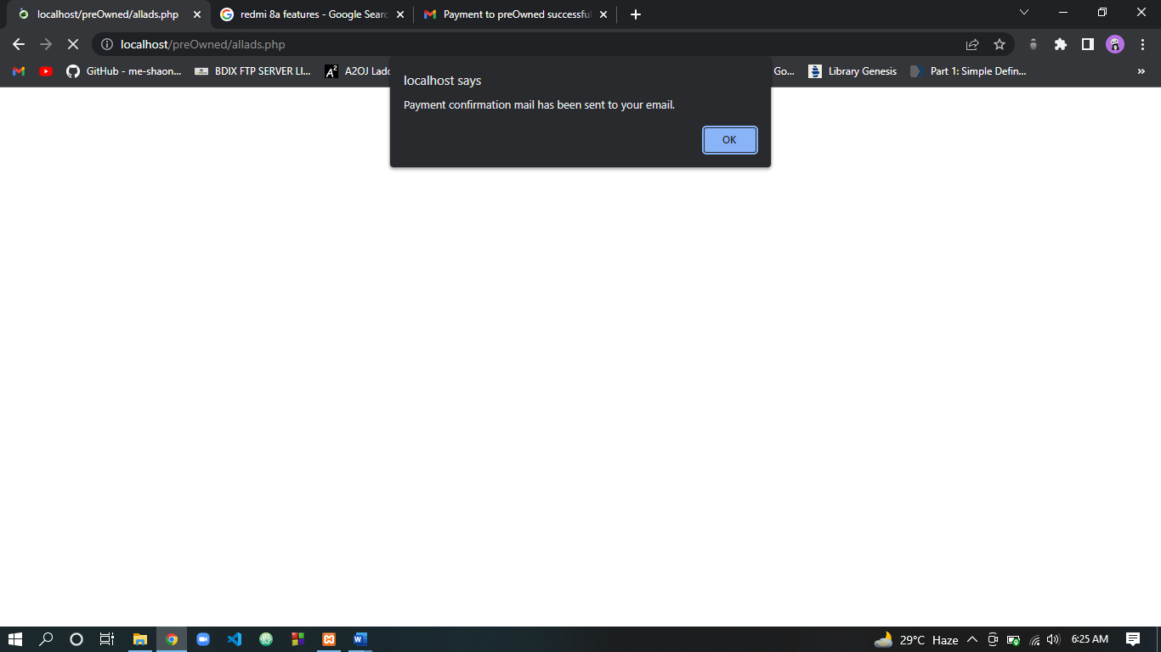

**Payment confirmation mail automatically sent**

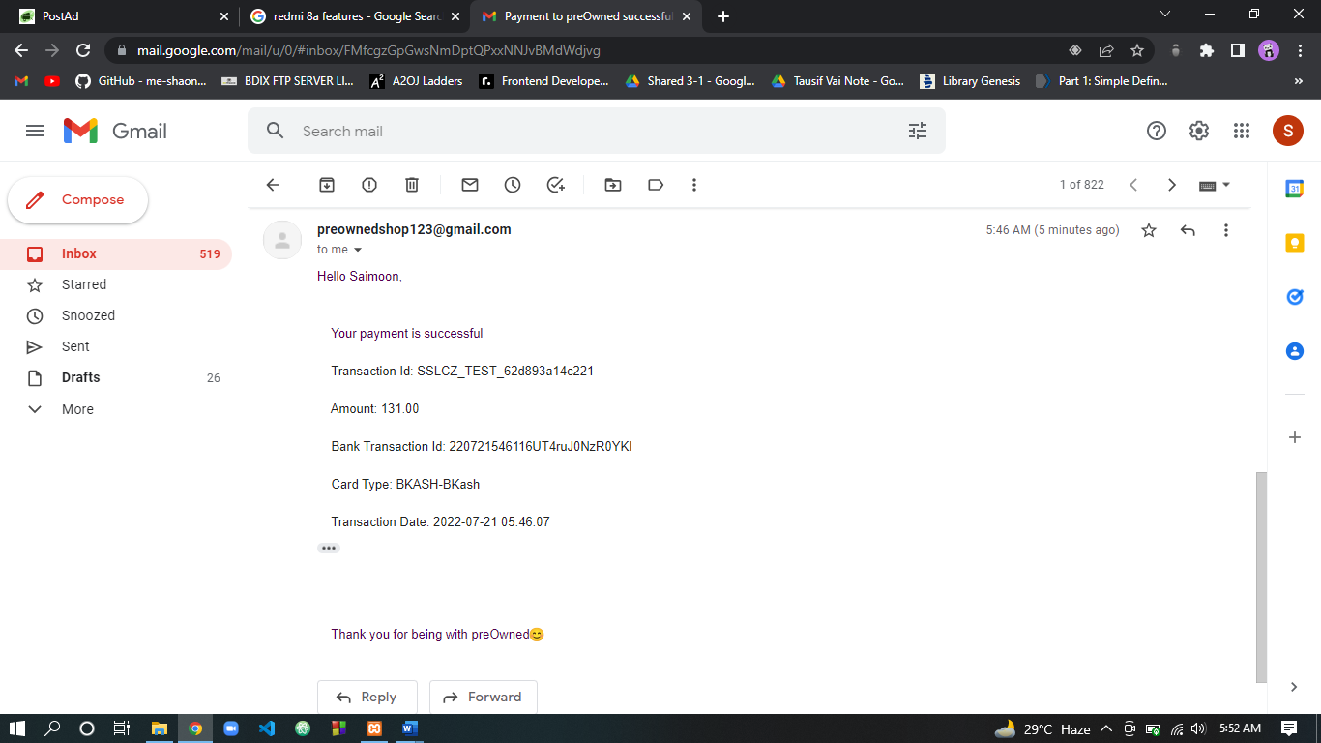

**2. Admin Panel:**

The admin panel has 3 activity.

1. Delete Ads.
2. Delete User.
3. Details about every ads, users and income.

There is an Dashboard where admin can easily see the latest ads posted on website by users. Admin can see the details of every ads and payment of that ads. Admin has also access about deleting inappropriate ads.

An admin can also delete user if he wants. If an account is not seams to like real then admin has the power to delete that user account and user account will be deleted permanently from database. Also all related ads and payment of that user will be also delete automatically.

An admin can also see the total number of user, total number of ads and total income of preOwned.

Here is a flow diagram of admin panel given below:

**Flow Diagram of Admin Panel**

Insert or Modify data on database in back end

Delete ads

Delete users

See details about all ads, payment and user

Admin

**Admin Login/Register**

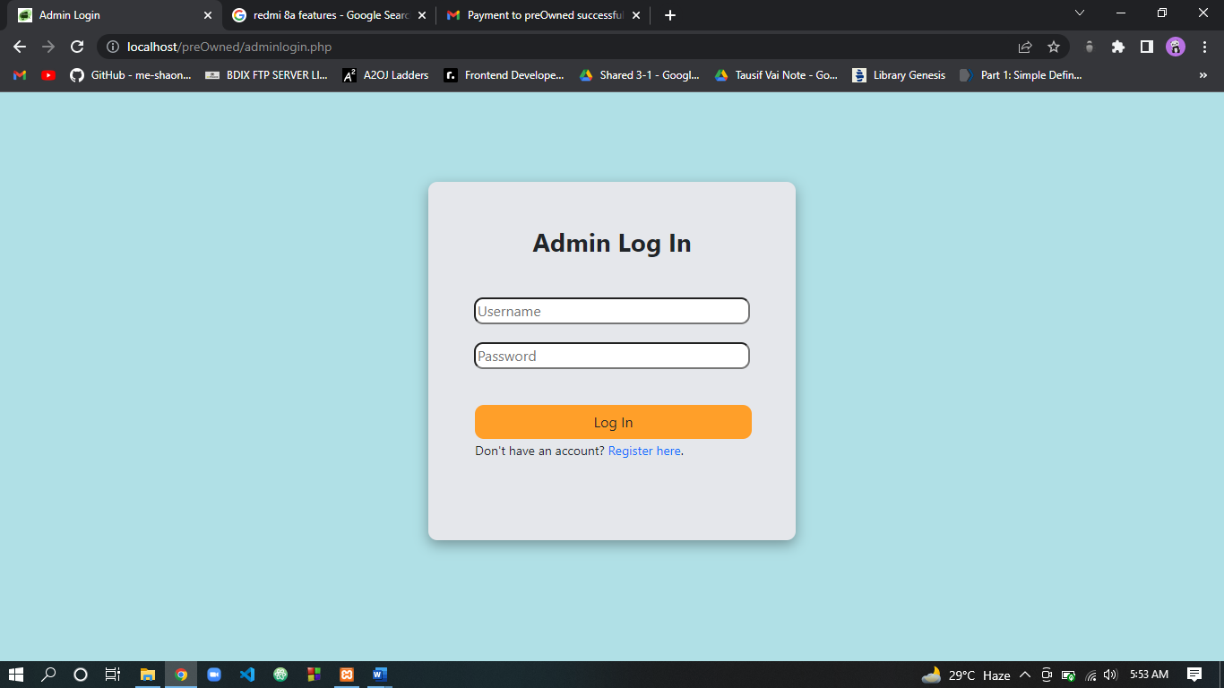

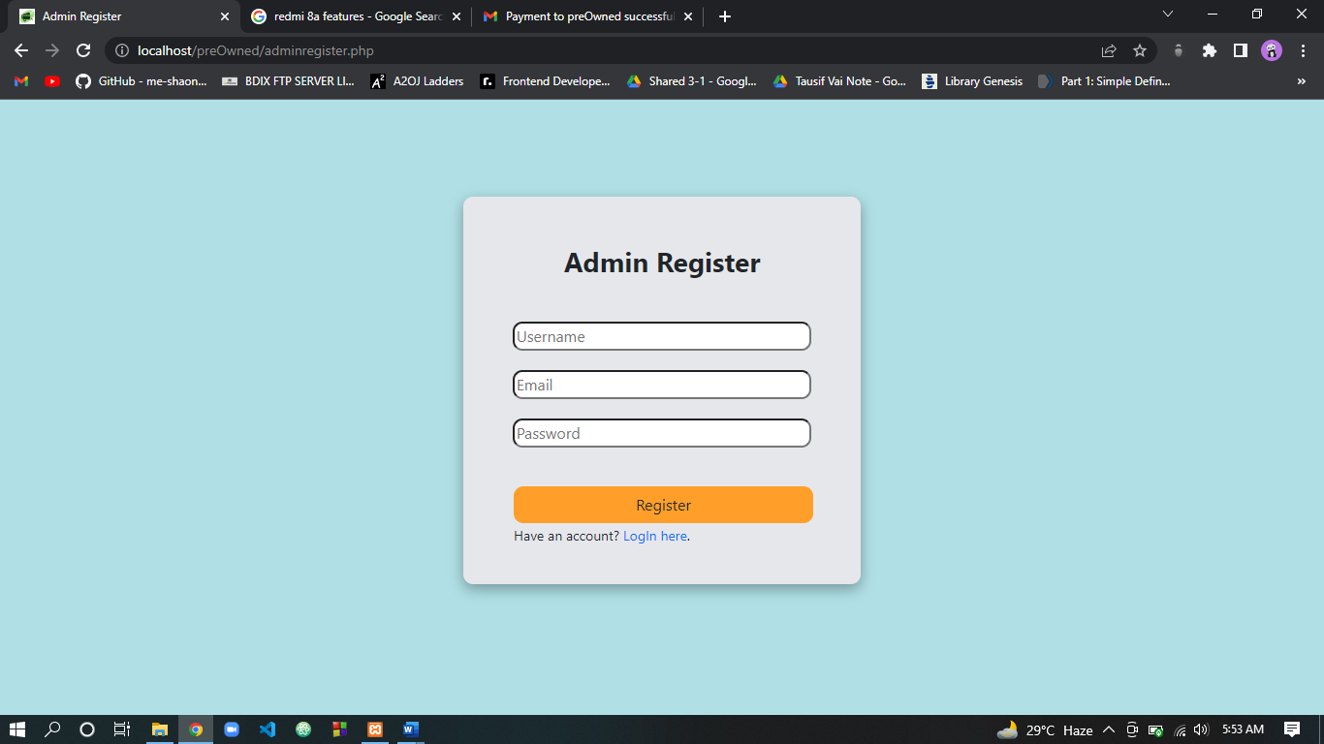

**Dashboard**

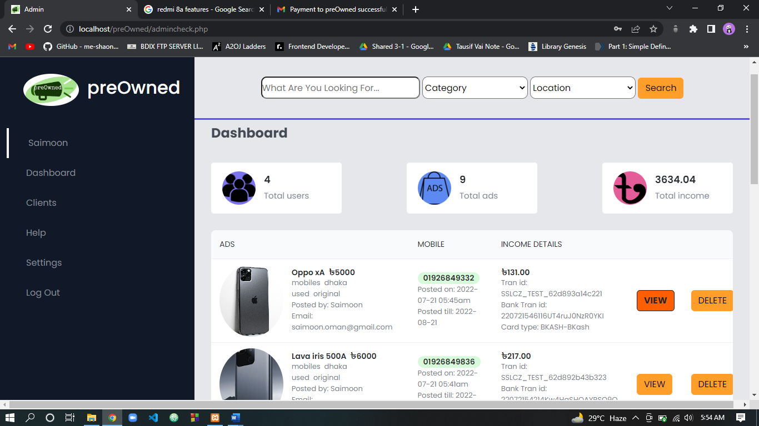

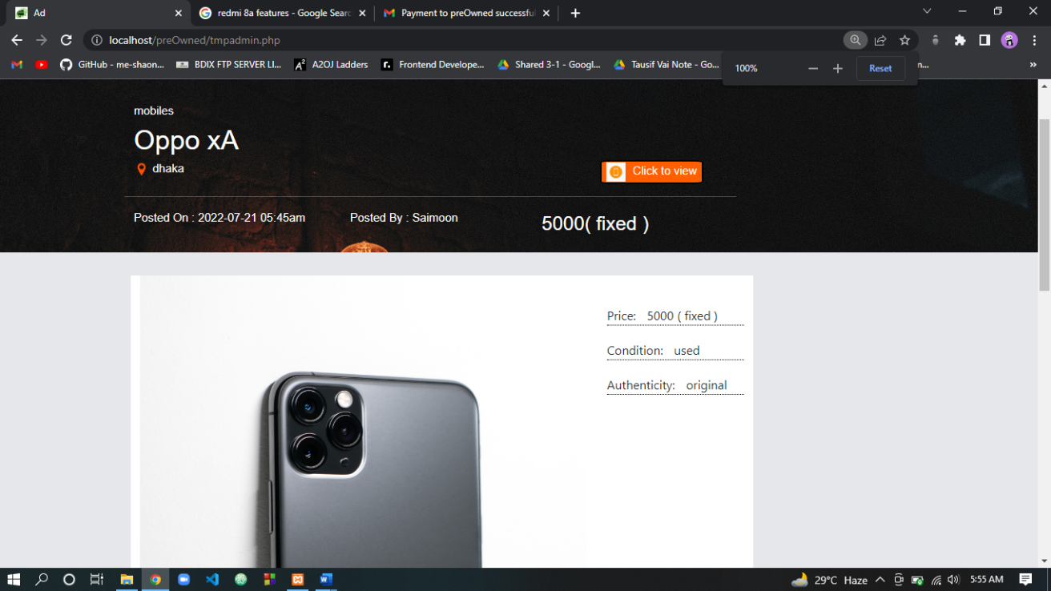

**Clients details**

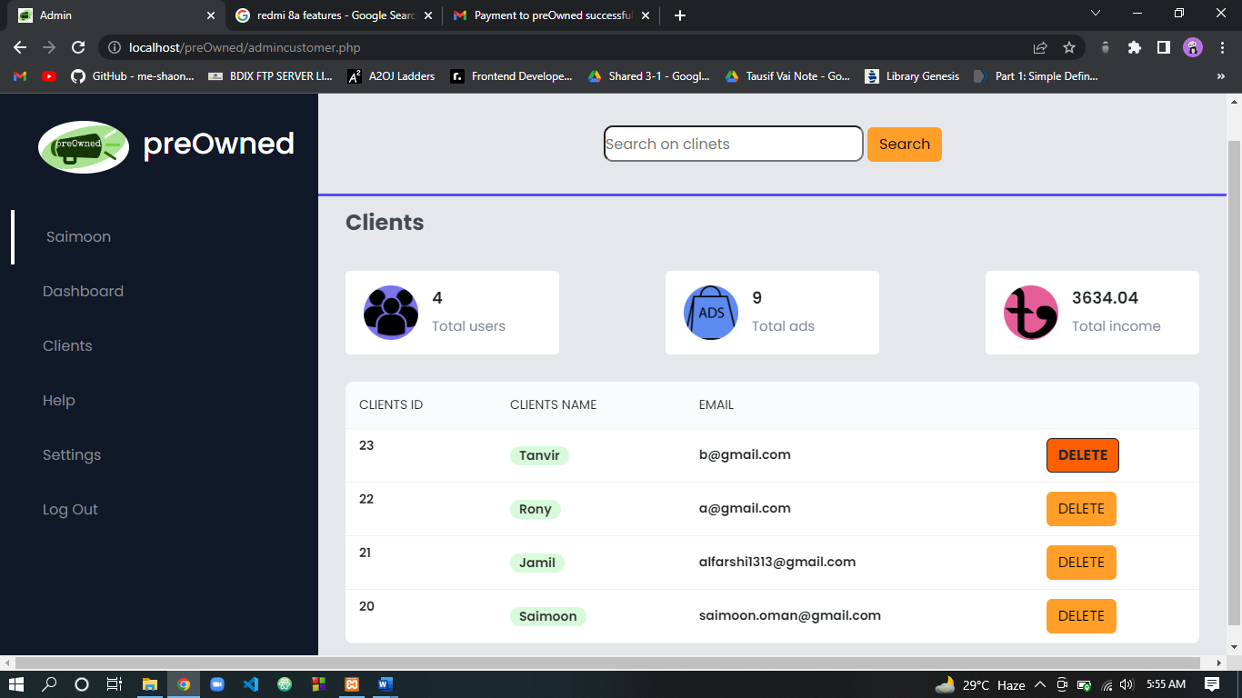

**Database Schema:**

admin_registration

userid (PK)

username

email

password

payment

pay_id (PK)

ad_id (FK)

user_id(FK)

tran_date

tran_id

bank_tran_id

amount

card_type

ads

ad_id (PK)

cat

loc

title

con

aut

feature

des

isnego

endDate

postdate

img1

img2

img3

img4

img5

phone

user_id (FK)

registration

userid (PK)

username

email

password

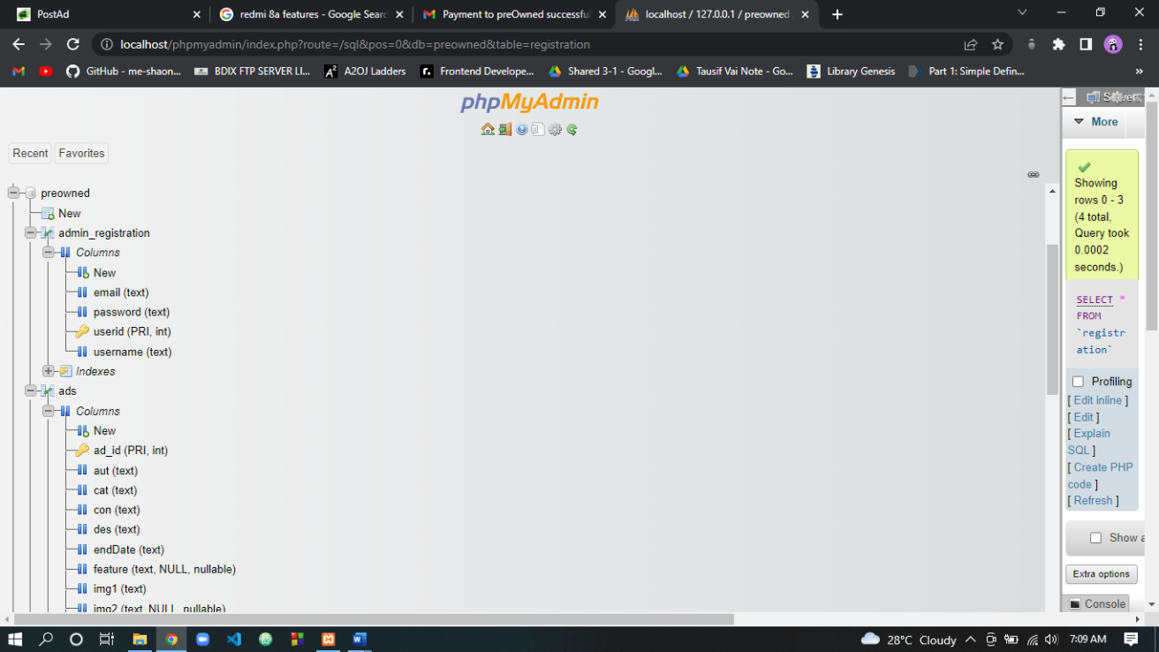

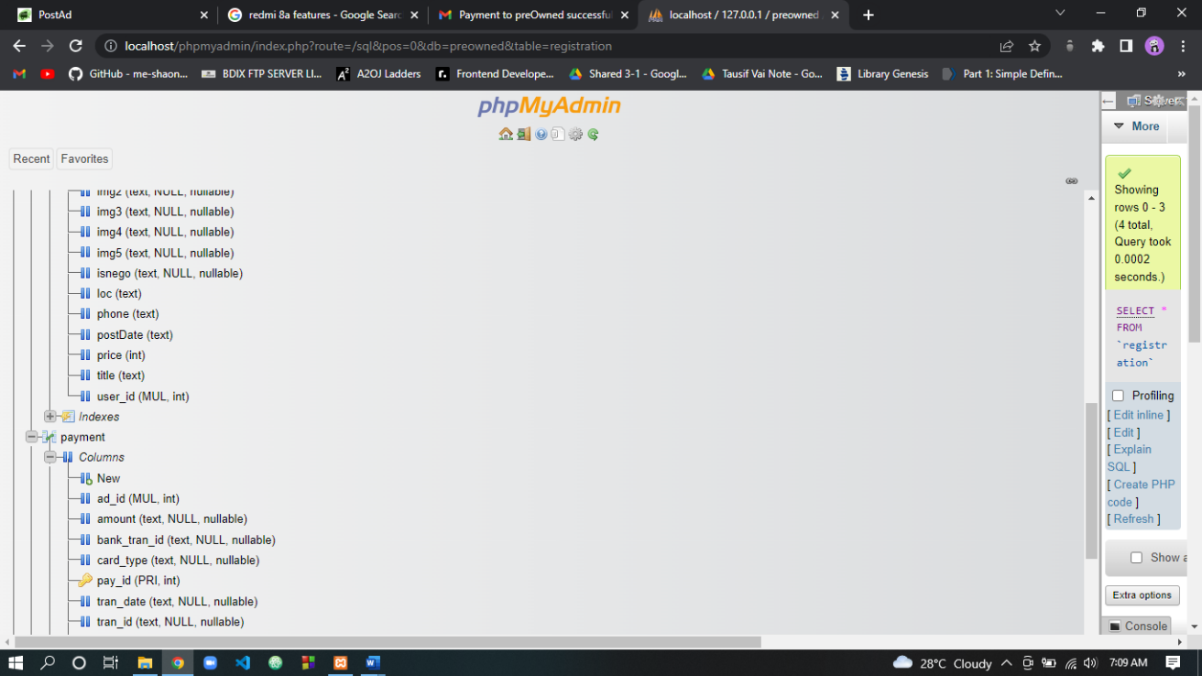

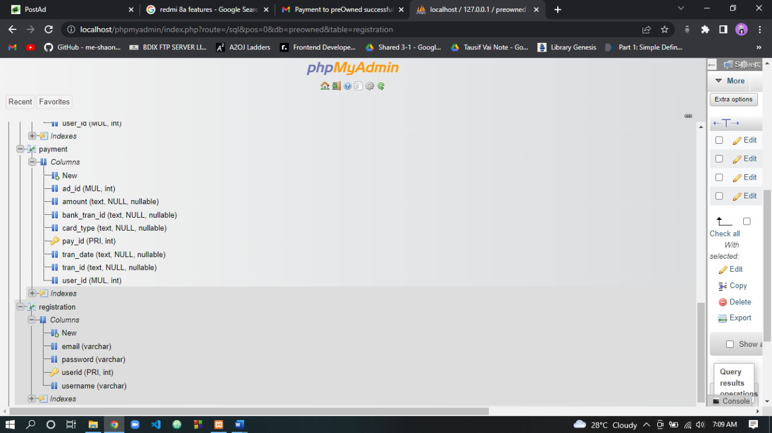

**Database Schema on phpMyAdmin**

**Discussion:**

This project was a demonstration of an advertisement website to post ads about old goods. It helps to connect buyer and seller to buy and sell preowned things. The service is available in only Bangladesh not globally. This website will fulfill users need of preowned product as preowned product is has much less price than new product. The sellers also sell their unused product and have some money in exchange of that. Mobile phone verification could not be implemented because no free API (Application Programming Interface) is found to do that. An sms API provider company named greenweb sms (<https://sms.greenweb.com.bd/>) don’t allow their service for testing purpose and have to buy sms from them by verifying business. So, it had not been possible to use sms API.

**Conclusion:**

By developing this project, I have got a clear idea about how a website can be built. Server programming language are used in this one project like HTML, CSS, JavaScript, PHP, Bootstrap. I have used local server (Apache and MySQL on XAMPP) to run this project. Relational Database model is used to design to the database of the whole system. API is used for payment method. This experience will help me in future for developing more beautiful website in future.

**Reference:**

* [https://www.youtube.com/](https://www.youtube.com/watch?v=oYe4ahkHjJs)
* <https://www.w3schools.com/>
* <https://getbootstrap.com/docs/5.1/getting-started/introduction/>
* <https://yandex.com/>
* <https://undraw.co/illustrations>
* <https://developer.sslcommerz.com/doc/v4/>
* <https://coryrylan.com/blog/>